1. **MAIN GOAL OF SOFIA SOCIAL NETWORK**

The main aim of SOFIA social network is to involve all the world population against forest fires winning their support for early detection through gamification.

By been registered on SOFIA App, users integrate a worldwide active vigilance network.

Every time they log in to the App, they are categorize depending on their past activity and collaboration.

1. **PROFILES HIERARCHY**

All new users have by default the junior Fire fighter badge, and as soon as they start actively to help AI identify feasible fires, they can grow up on the hierarchy.

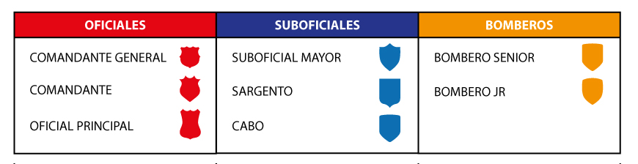

1. **TEAM DESCRIPTION and CHAIN OF COMMAND**

* **BRIGADE**: Brigade is set up by 10 fire fighters and one corporal.
* **FIRE STATION**: Fire station is set up by 4 brigade.
* **SERGEANT**: Manages 2 Brigades.
* **NOC:**  Manages 1 Firestation.
* **MAIN OFFICIAL**: Manages 2 Firestations.
* **MAJOR:** Manages 4 Firestations.
* **COMMANDING GENERAL**: Manages 8Firestations.

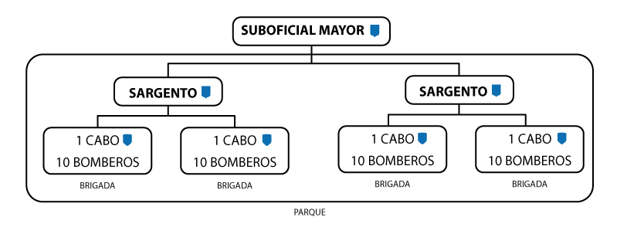

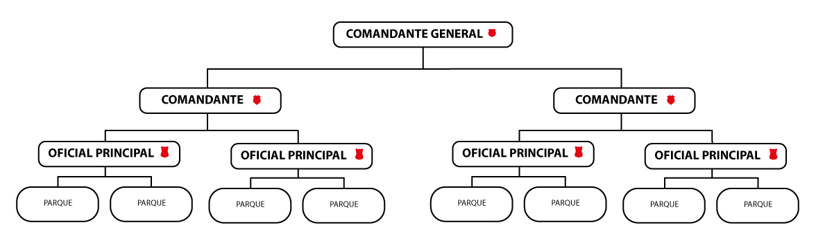

1. **GAMIFICATION**

Users taking part trough SOFIA on this worldwide active vigilance network will receive on their mobile random images that may be related with forest fire evidence (colum of smoke, heated areas, etc), and should indicate with an intuitive and easy design, whether is it a real potential fire or not.  
By doing this AI will learn from the decisions the users will take.

Every report send by each user will be analyze by an algorithm to score it. This score will determine how many points will be given to the user, and total points will determine local, national and worldwide ranking off forest fires helpers.

1. **SCORE CRITERION**

Users reports of SOFIA on this worldwide active vigilance network will be used by AI to define points that will allow the users to grown on the hierarchy as follow:

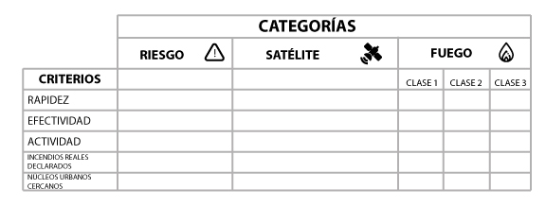

1. **RANKING**

Users play on worldwide range, with the unique propose of preventing fires.  
  
Total points will determine local, national and worldwide ranking off forest fires helpers.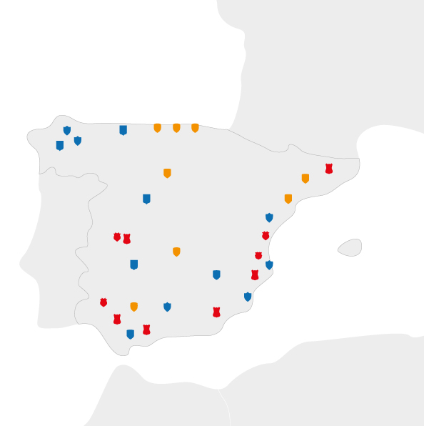

1. **COLLABORATIVE INTELLIGENCE**

SOFIA social network is based on another existing collaborative example, the SETI project, that works as a worldwide collaborative network with a common goal.

.